**Interaction Notes**

1. Dashboard – Mailroom

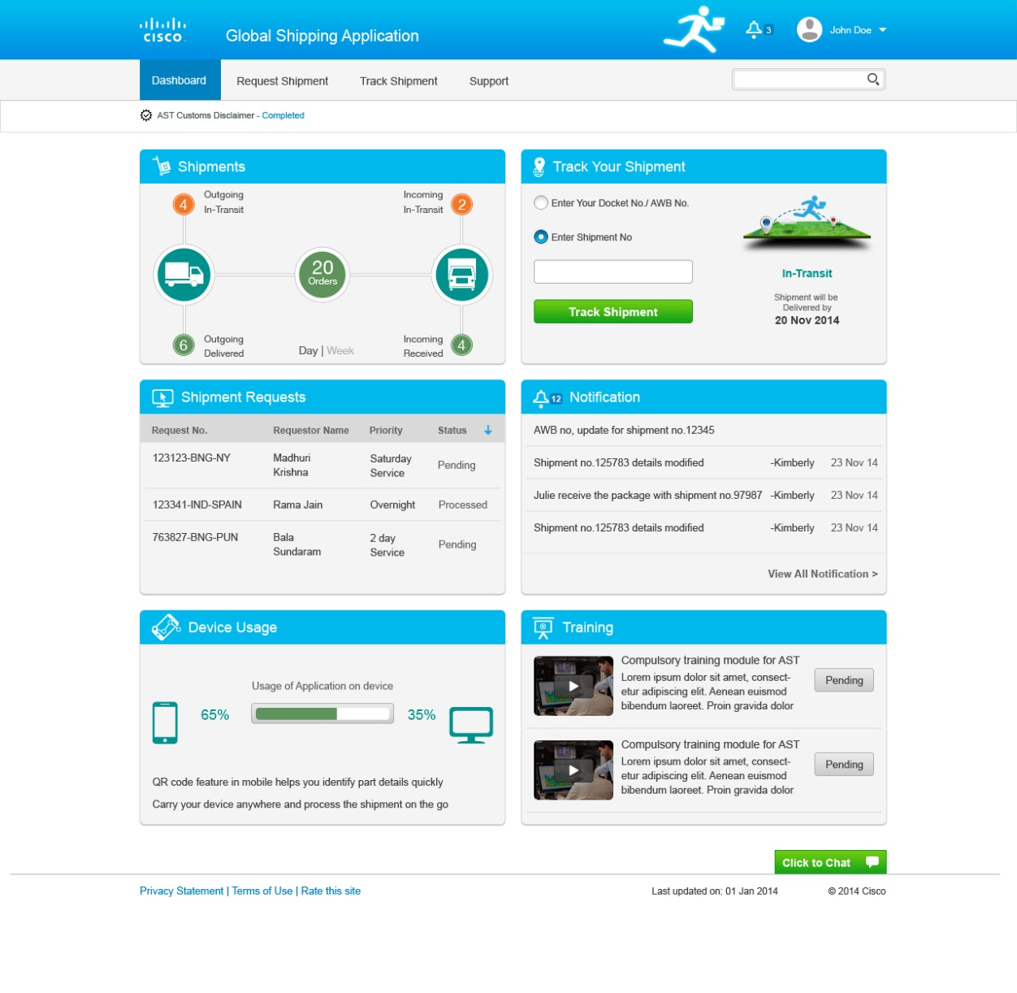

Outgoing In-transit is link and takes user to track shipment with the filter applied current week and day. Similar for others

The image appears/changes only on entering any shipment no, the image will appear based on the status. The text input on typing should dynamically show the list of shipments to or from the user.

Onclick scrolls to notification tile.

Replace DEVICE USAGE with Bulk shipment. Refer wireframe below

Opens a dialog box with chat option

It’s just status indicator and not an action button

Opens a video overlay

Appears if user has agreed for the disclaimer

Add Create Shipment button here

Data can be viewed for current week and day

Need a view all link which will lead the user to Track shipment page

View all notifications takes to notifications listed

Every entry is clickable and takes to the respective page.

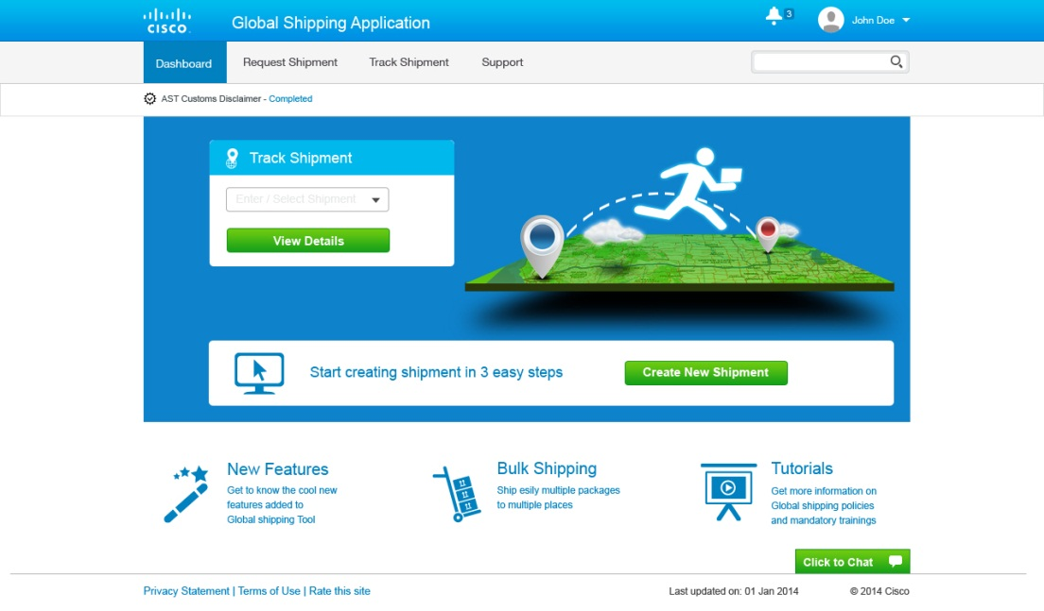

Bulk Shipment



**Bulk Shipping**

Ship to multiple locations and multiple packages

Download the template, fill details and create multiple requests at one go.



**Bulk Upload**

Ship to multiple packages in one shipment

Download the template, fill details and upload in package details of "Create Shipment" flow.



Bulk Upload-Template.xls

Bulk Shipping-Template.xls